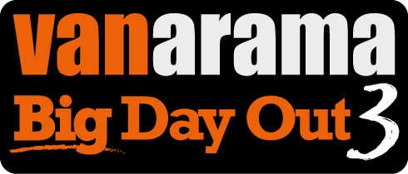

The Vanarama National League has released details of ticket information for their annual flagship final at Wembley Stadium connected to EE, which takes place on Sunday 14th May 2017 at 3.00pm.

All ticket sales will again be handled direct by Wembley National Stadium Ltd (WNSL) and for convenience to purchasers comes with an option for 'Print at Home' (PAH). Tickets will be only be available on line and are priced as follows:

EARLY BIRD – 12th December – 28th February
Category 1:
Adults: £20
Seniors (Over 60): £10
Under 16: FREE **
(** 1 free U16 ticket with each ticket sold at Adult or Senior price).
Additional tickets for Under 16 can be purchased at £5 each.

Disabled seating allocation will be available through WNSL as usual for stadium events and details are accessible on line if this is the chosen preference.

Early Bird sales are made even more attractive by no booking fee being charged.

Postal sales will be charged throughout at a standard rate of £2.50 per order (limited to a maximum of 20 tickets per order) whilst £1 will be charged for all PAH sales.

GENERAL OPEN SALE – these only go on sale when the two finalists are confirmed:
Category 1: £41 (no concessions)
Category 2: £36 and £18 (Under 16's)

Note:
Actual tickets will NOT be issued to purchasers either by post or available via PAH until the two competing finalist clubs are confirmed. As previously undertaken this assists to ensure seated allocation is made in blocks for any supporters of clubs wishing to be in the same area. In order for this to be offered, when on line transactions are made the purchaser will be required to nominate which National League member club they align themselves to or they may indicate a totally neutral bias and select that alternative on screen option.

Such data provided by the purchaser ensures any supporter of a club who may reach the Final is not disadvantaged by selecting to purchase an Early Bird ticket and they are assured of being in the correct area of the stadium allotted to each finalist club.
Purchaser of Early Bird tickets should note there is no refund if they
select this option rather than wait until tickets go on General Open Sale.

